<https://onejira.verizon.com/browse/NTSWSC-1121>  
Env-SIT   
Instance-uat5  
TC_01 Verify that only one Site ID can be set to 'YES' for SARF within an Initial Build Project  
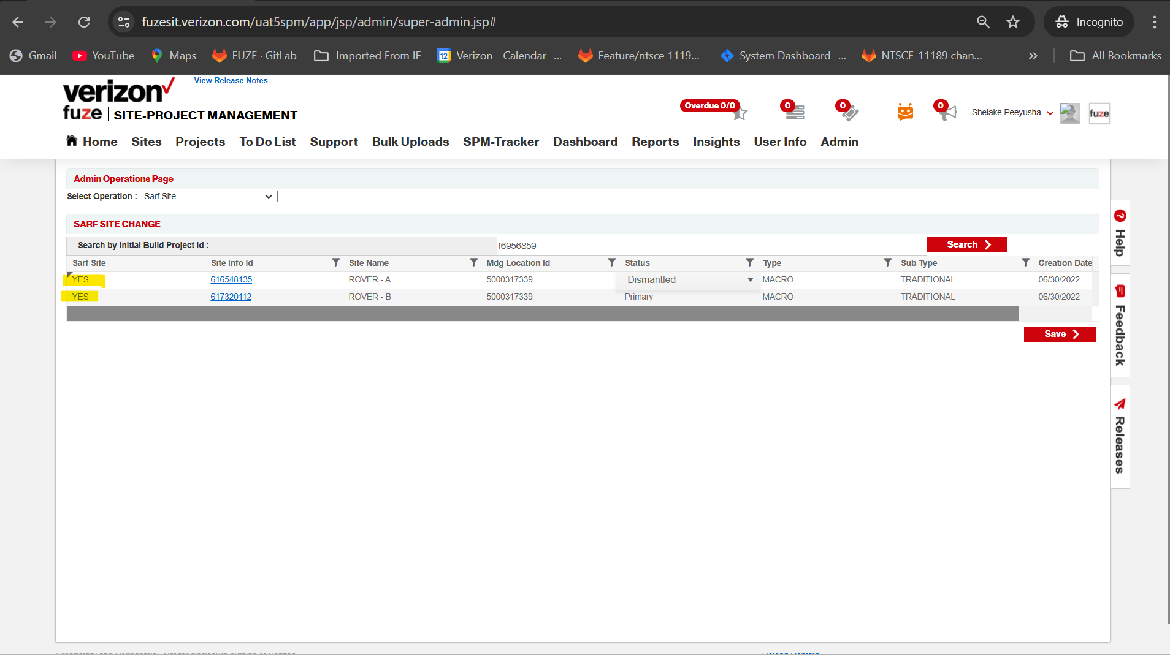  
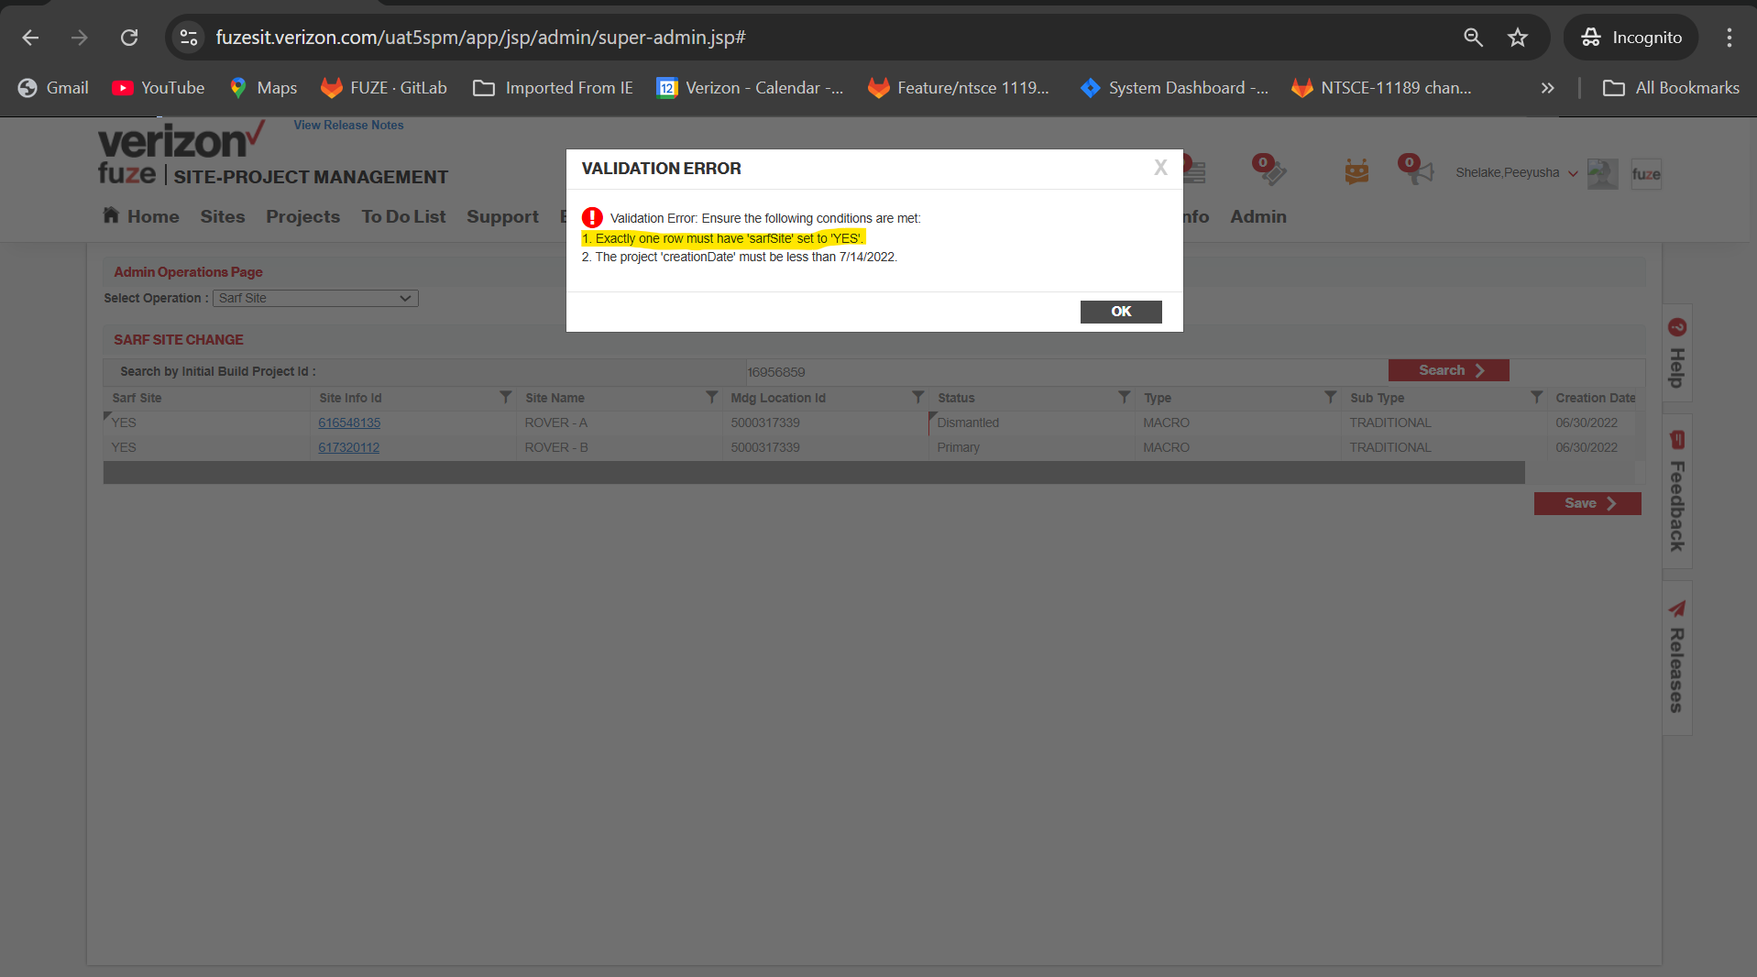  
  
TC_02 Verify the system prevents SARF SITE field changes for projects created after 7/14/2022

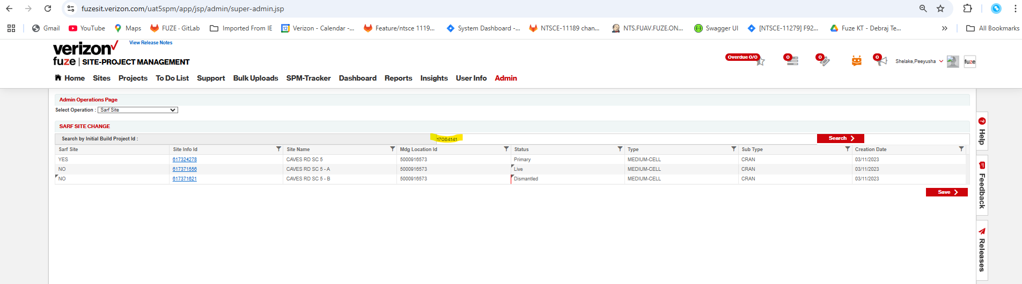  
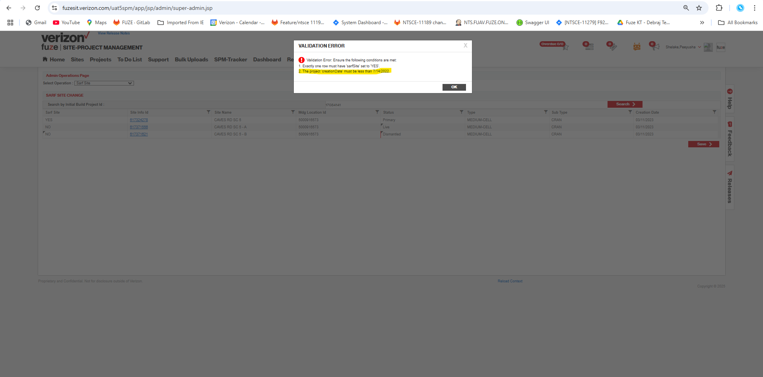  
TC_03 Verify successful update of SARF Site to 'YES'  
  
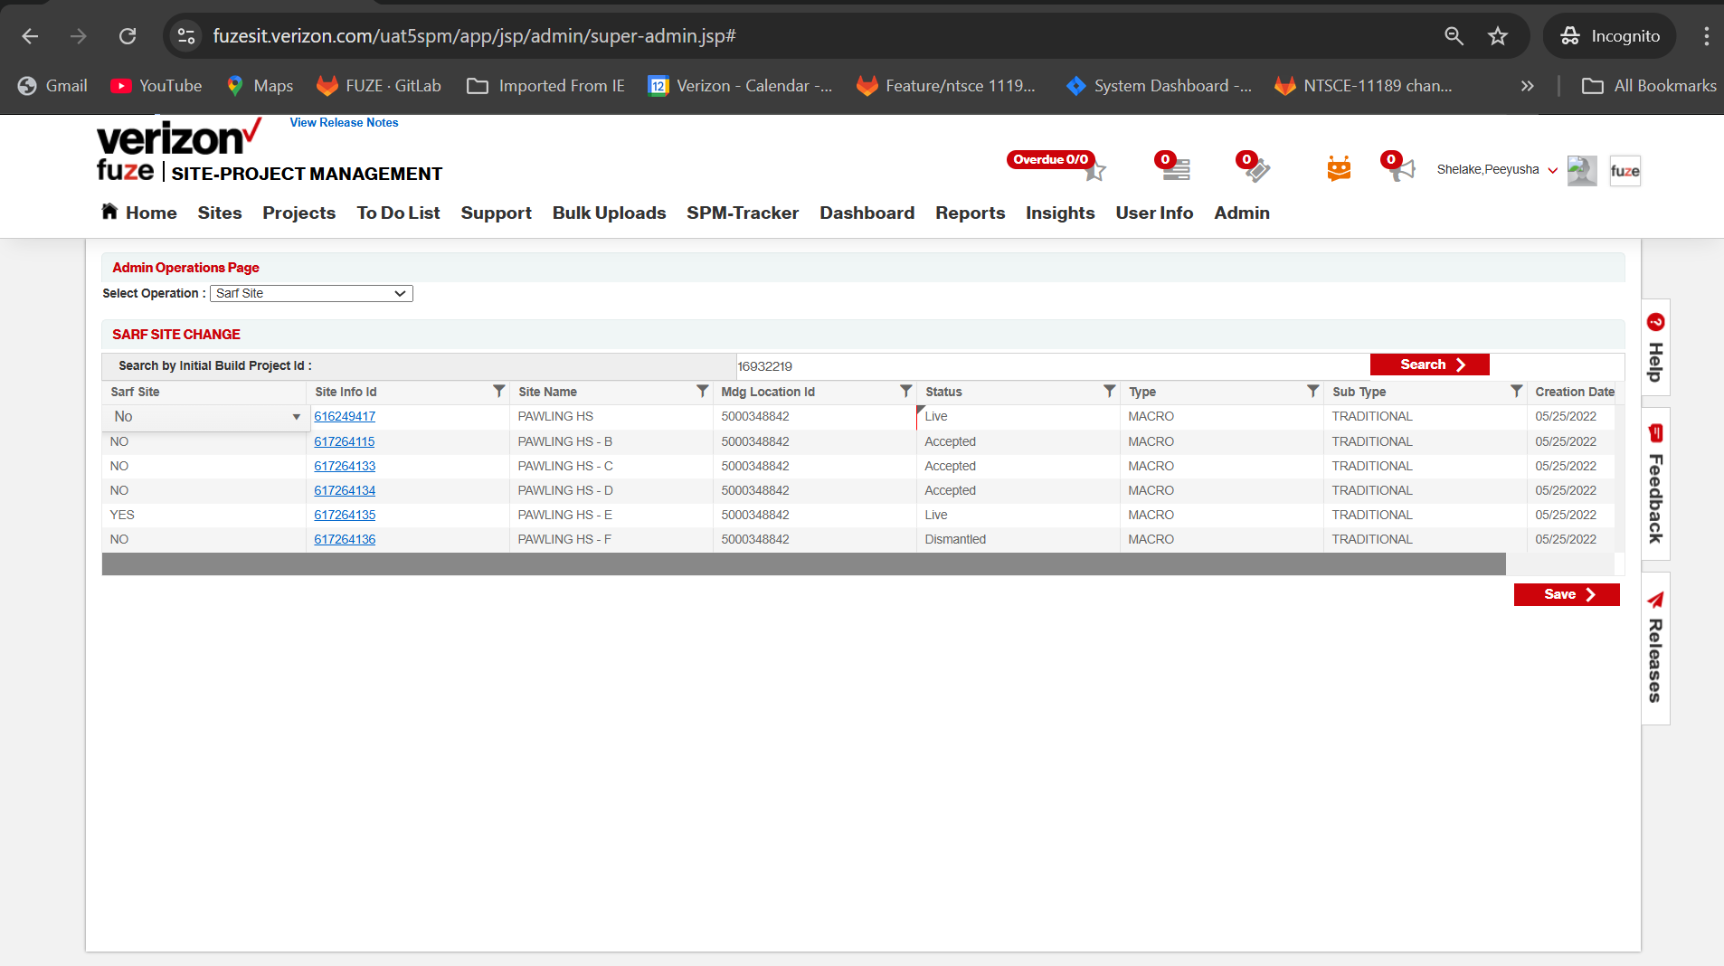  
  
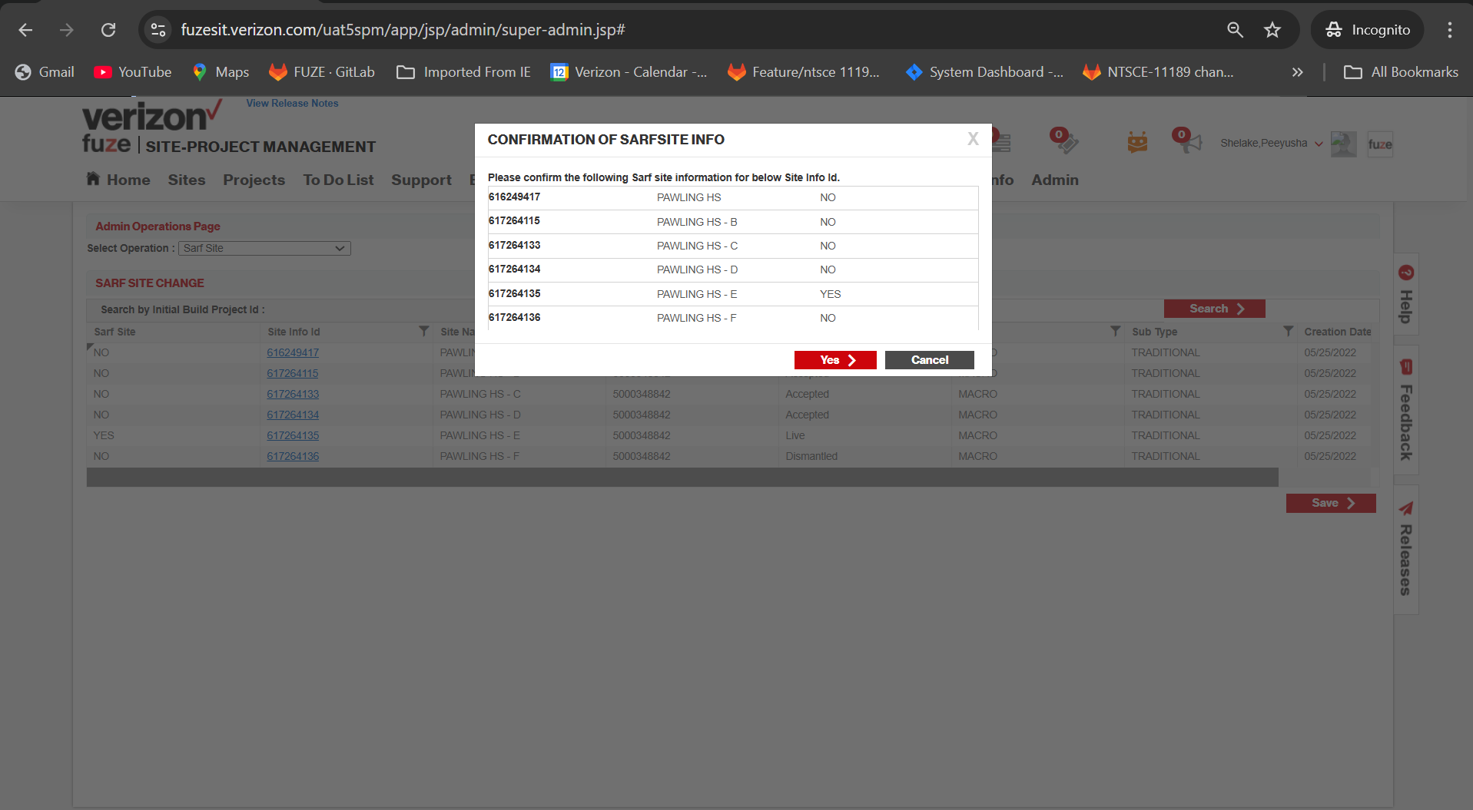  
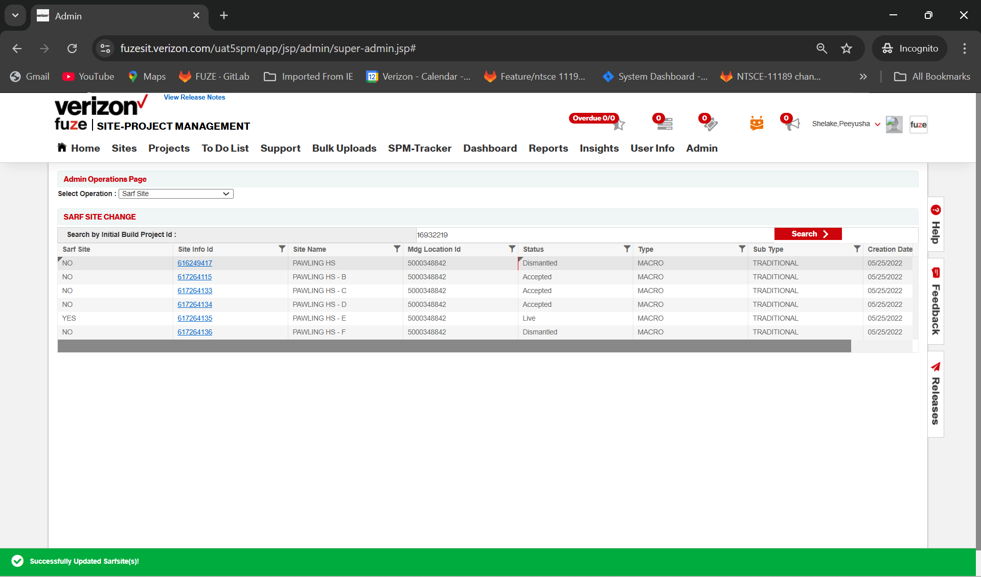  
  
TC_04 Verify error handling when searching with a Project ID that is not of type 'Initial Build'  
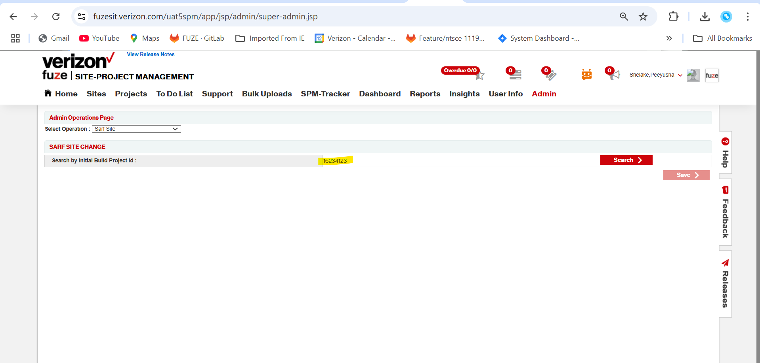  
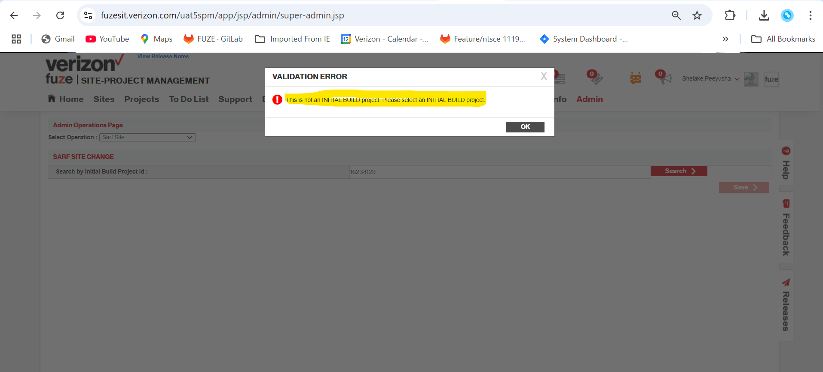  
TC_05 Verify the new privilege is not visible on the privileges management page.  
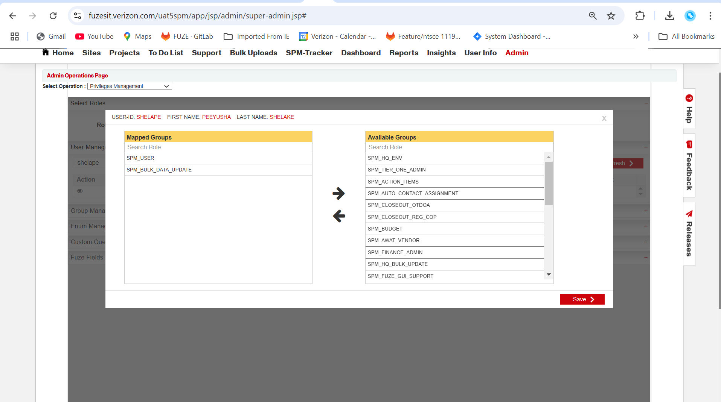  
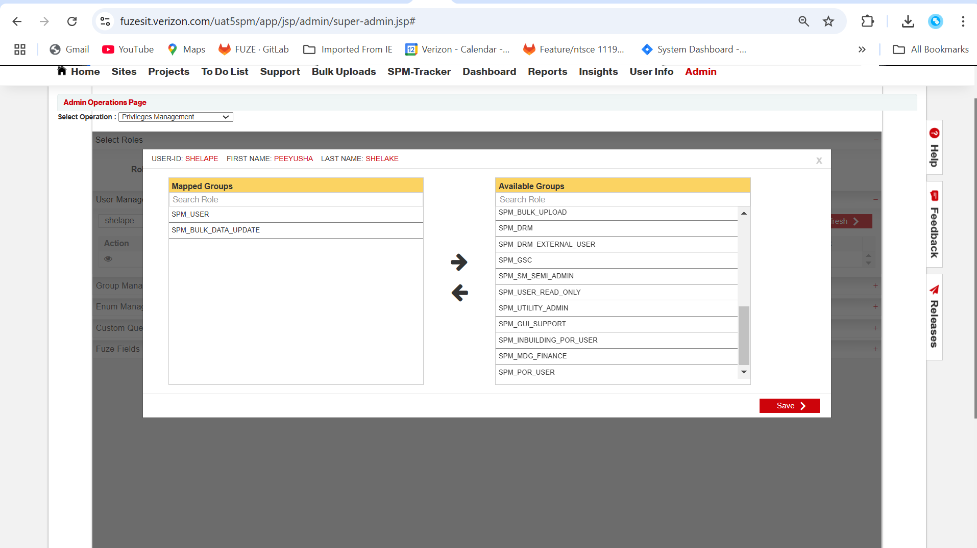  
 **Tracker Side Evidences:  
https://fuzesit.verizon.com/tracker/app/jsp/admin/super-admin.jsp#**TC_01 Verify that only one Site ID can be set to 'YES' for SARF within an Initial Build Project  
before;  
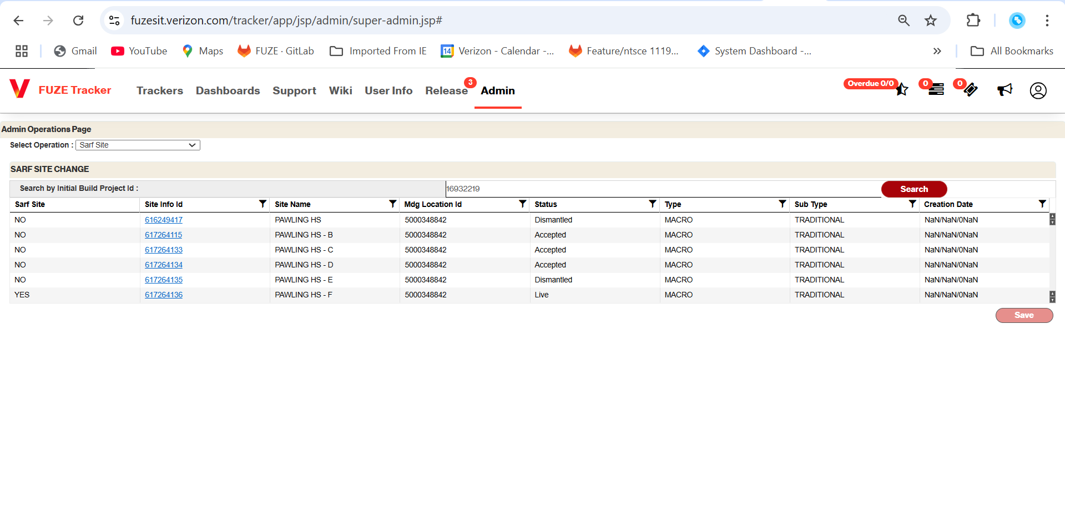  
After:  
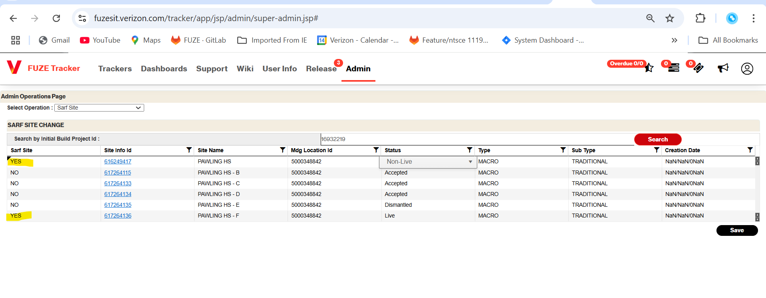  
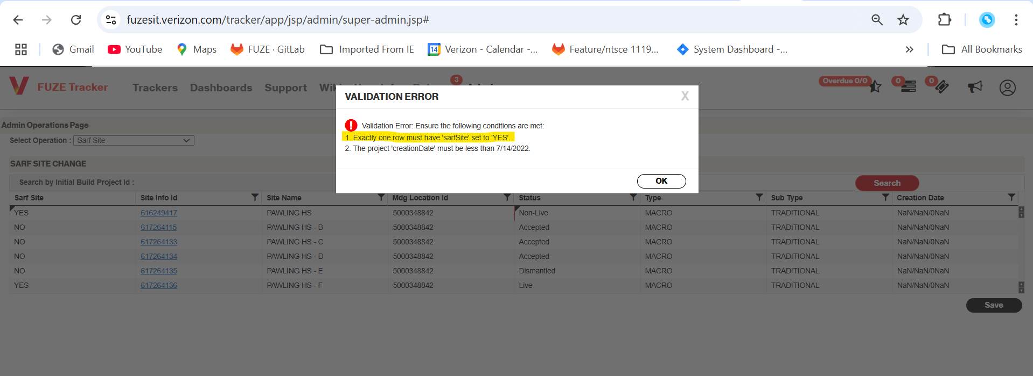  
TC_02 Verify the system prevents SARF SITE field changes for projects created after 7/14/2022  
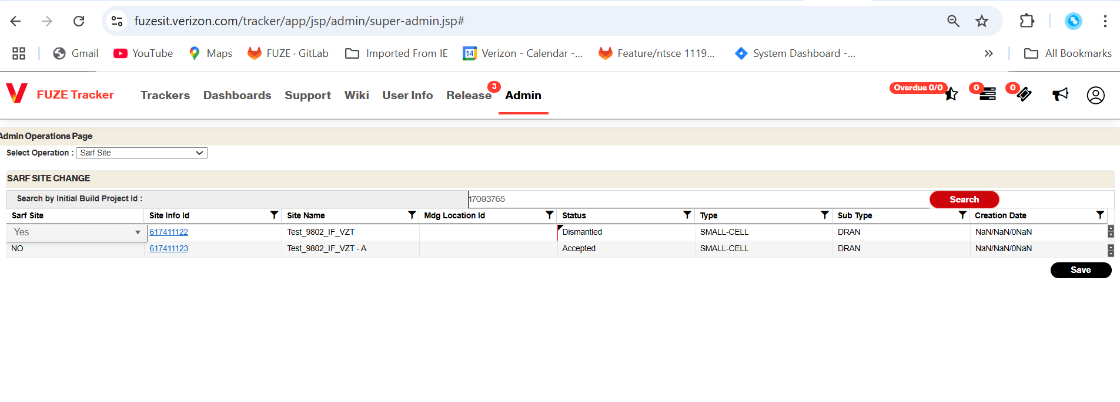  
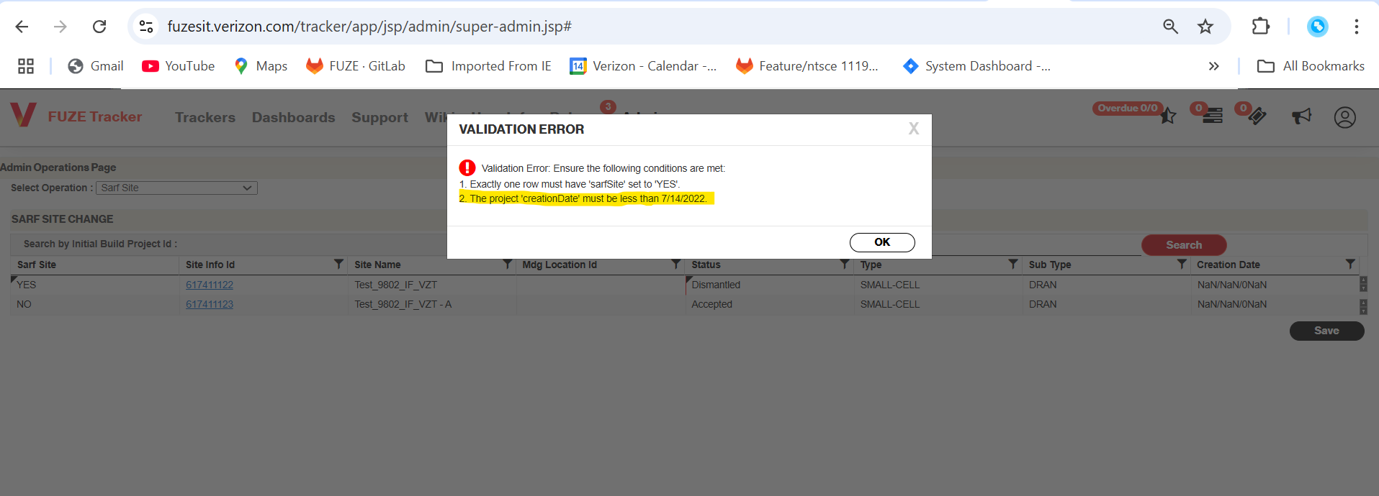  
TC_03 Verify successful update of SARF Site to 'YES'  
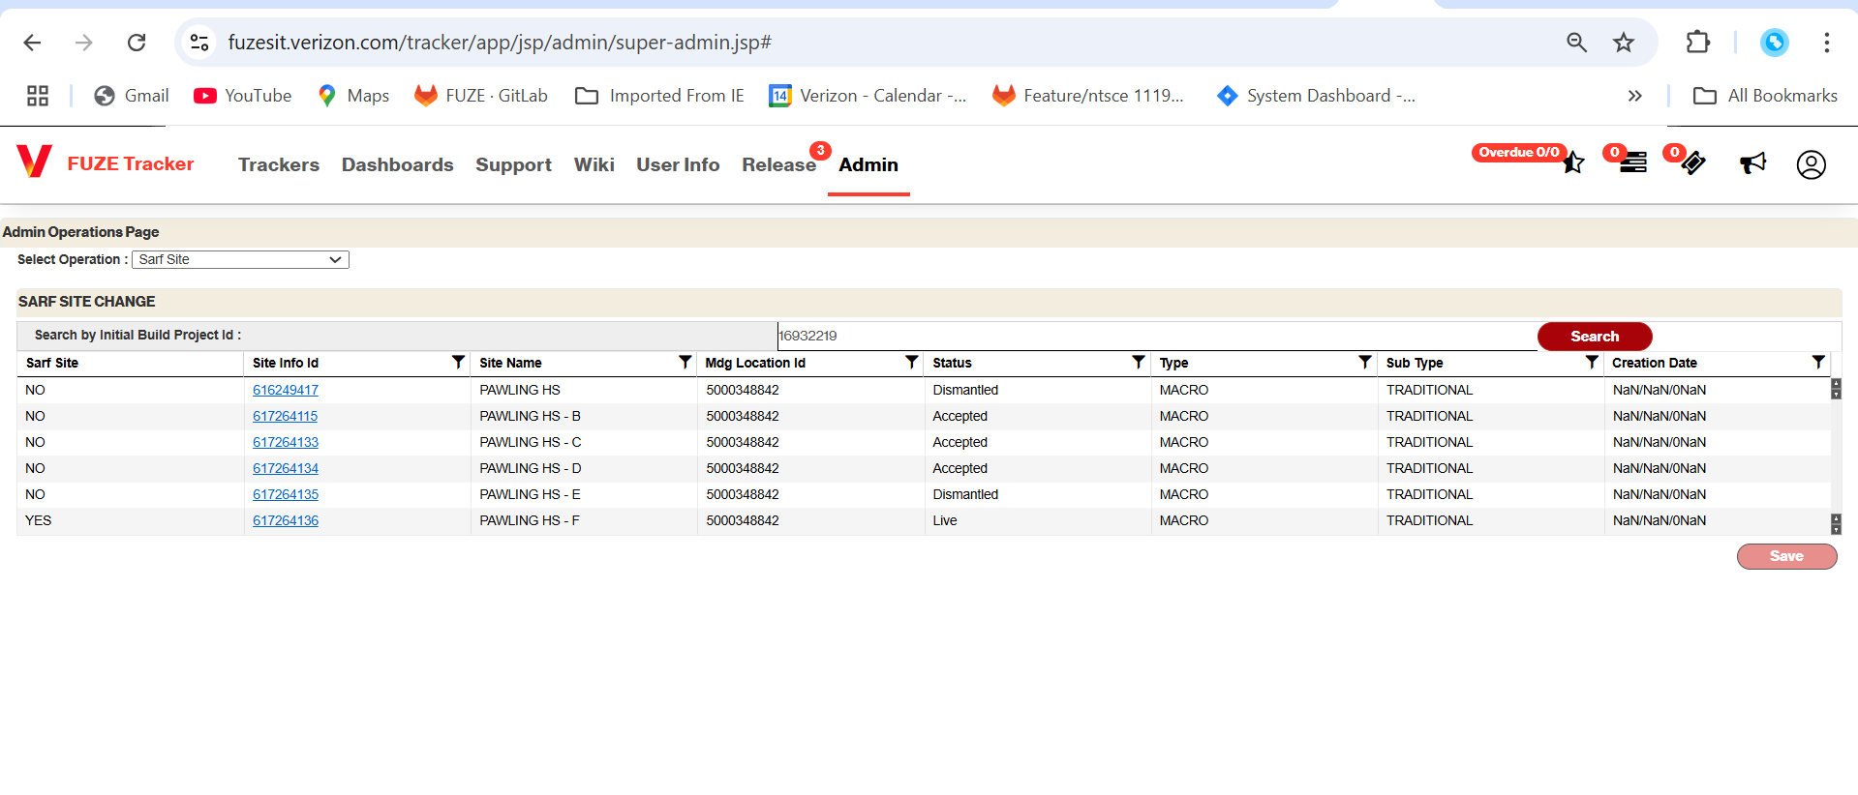  
  
TC_04 Verify error handling when searching with a Project ID that is not of type 'Initial Build'  
TC_05 Verify the new privilege is not visible on the privileges management page.